Final ESG Generated-vs-Actual Analysis
Integrated synthesis of Python text metrics and LLM-style qualitative analysis

Executive Summary
The DataNXT-generated ESG reports reproduce the broad ESG structure of the official benchmark reports, but they are much shorter and more standardized. The official reports remain stronger as audit-ready disclosure documents because they contain more quantified evidence, reporting-boundary detail, framework language, and company-specific risk information.
- Closest generated-vs-actual vocabulary match: Microsoft with TF-IDF cosine similarity of 0.2954.
- Lowest generated-vs-actual vocabulary match: SAP with TF-IDF cosine similarity of 0.2473.
- Across all four companies, generated reports are compact summaries rather than substitutes for official ESG or annual-report disclosures.
- The strongest qualitative limitation is not direct contradiction, but missing depth: official reports include disclosure boundaries, assurance language, materiality framing, tables, and operational metrics that generated reports compress.

Data and Source Basis
Company | Generated source | Actual benchmark source
Amazon | Amazon_ESG_Report_Generated.docx | 2024 Amazon Sustainability Report - 2024-amazon-sustainability-report.pdf
Microsoft | Microsoft_ESG_Report_Generated.docx | microsoft_2025_environmental_sustainability_report.pdf; microsoft_2025_impact_summary.pdf
SAP | SAP_ESG_Report_Generated.docx | SAP 2025 Annual Report Form 20-F.html
Zalando | Zalando_ESG_Report_Generated.docx | zalando-se_en_full-csrd-esrs-report_annual-report_2025.pdf

Python Analysis Findings
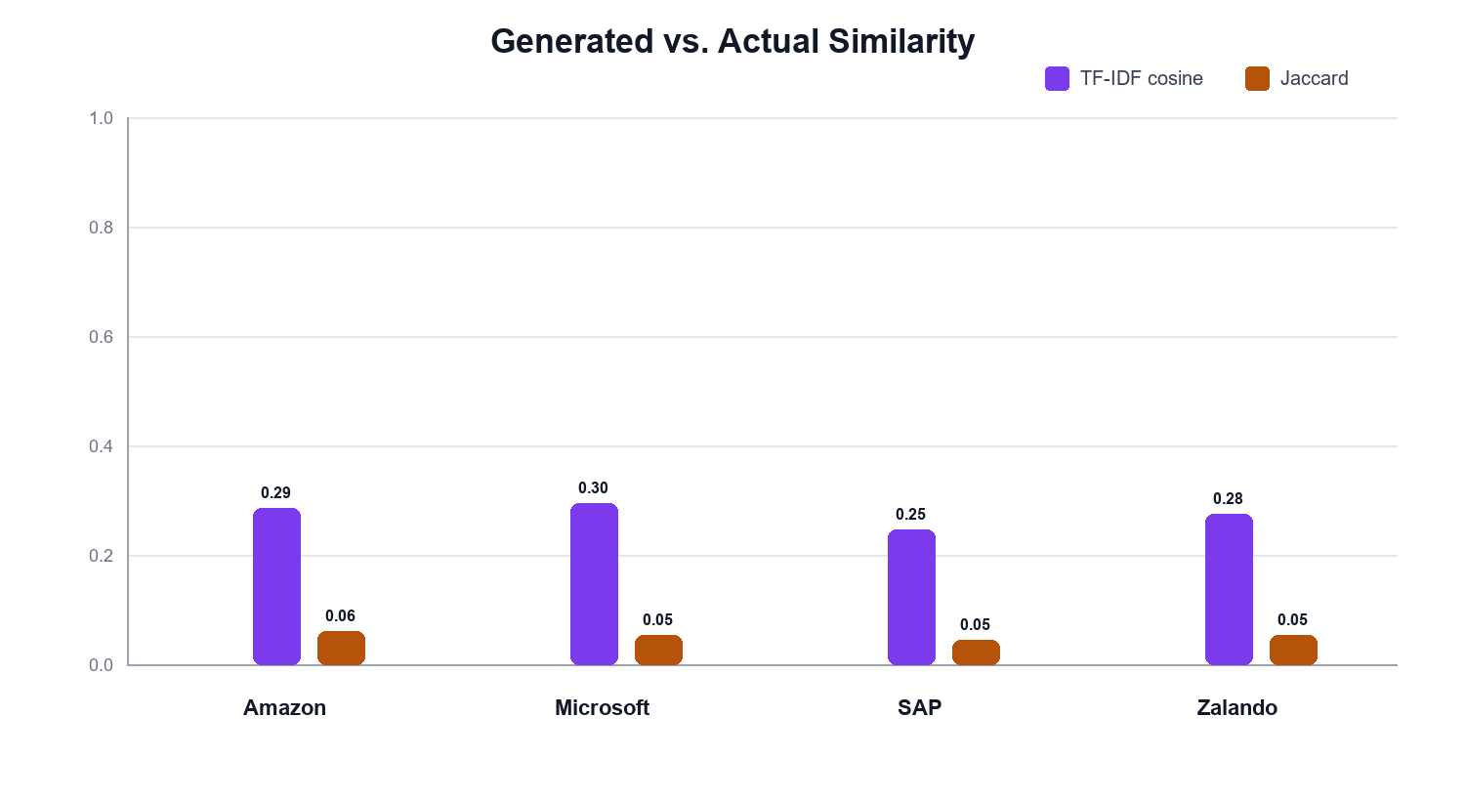
Figure 1. Similarity between generated and official benchmark reports.
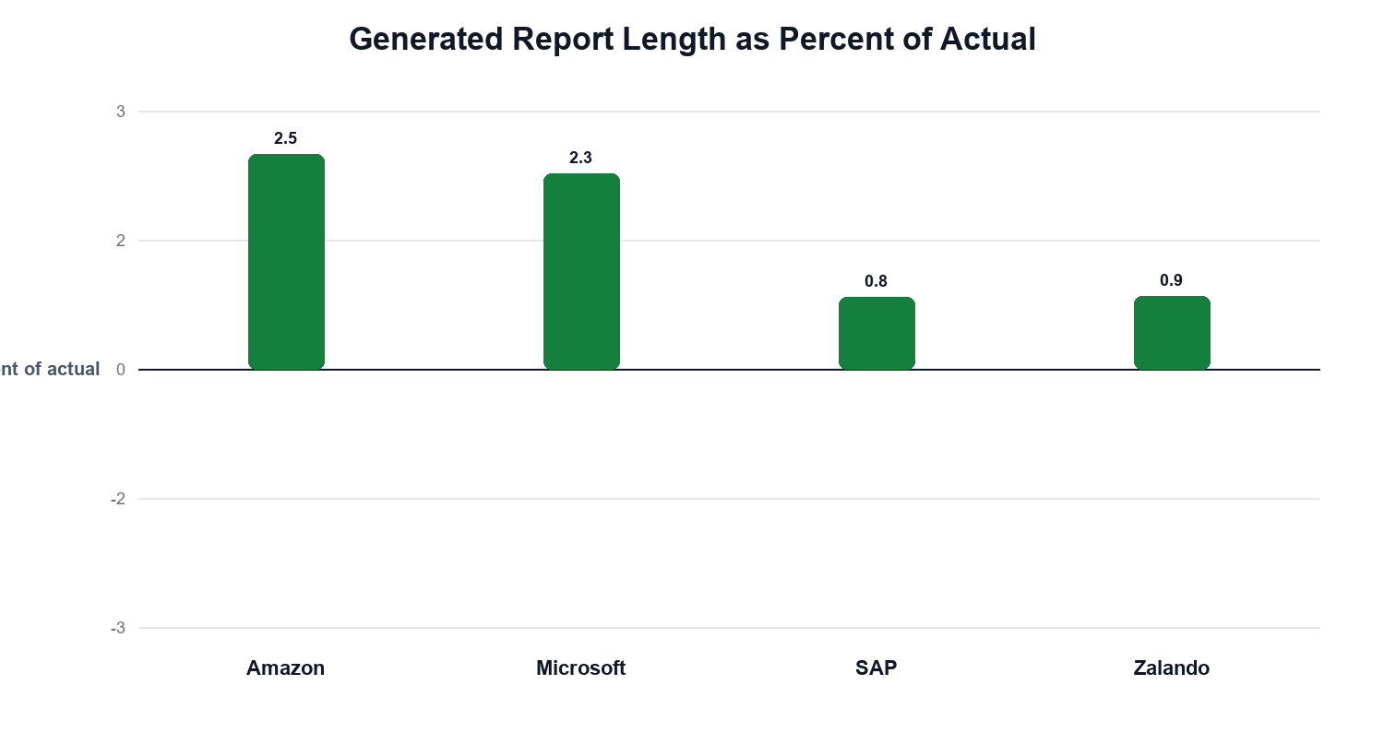
Figure 2. Generated report length as a percentage of actual report length.
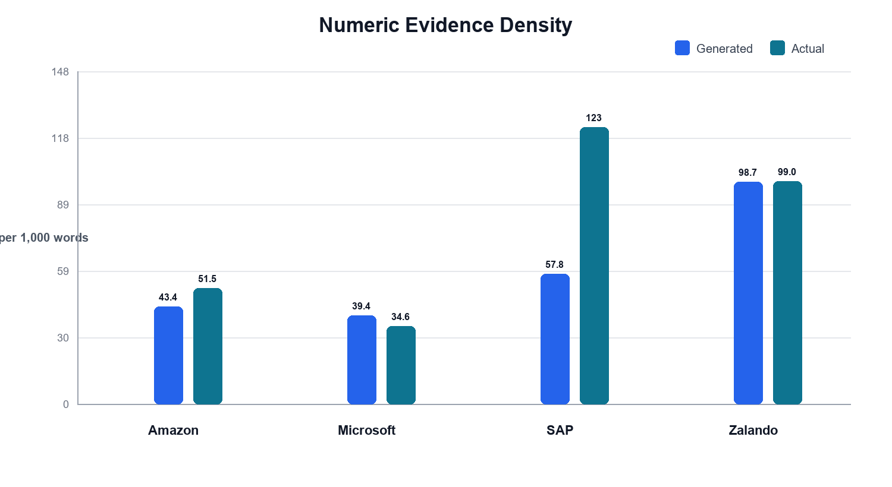
Figure 3. Numeric evidence density in generated and actual reports.
The similarity scores are modest across all companies. This is expected because official reports are much longer and contain large sections of regulatory, financial, assurance, and framework-specific disclosure language. Jaccard similarity is especially low because it compares cleaned vocabulary set overlap and is sensitive to the much broader vocabulary in actual reports.
Company | TF-IDF cosine | Jaccard | Generated length as % of actual | Numeric density gap
Amazon | 0.2873 | 0.0615 | 2.51 | -8.09
Microsoft | 0.2954 | 0.0542 | 2.29 | 4.81
SAP | 0.2473 | 0.0455 | 0.84 | -65.29
Zalando | 0.2766 | 0.0548 | 0.86 | -0.35

Metric Definitions
The Python analysis uses transparent count-based and similarity-based indicators. Density metrics normalize counts by word count, so they are useful for comparing generated and actual reports of very different length, but they should always be interpreted together with the absolute document size.

Document-Level Metrics
Metric | Calculation | How to read it
Word count | Number of regex-tokenized word tokens in the extracted report text. | Shows the document size. Generated reports are intentionally much shorter than official benchmark reports.
Sentence count | Number of sentence-like text segments after splitting on sentence punctuation. | Helps compare structural density and how much narrative material is available for analysis.
Average sentence length | Word count divided by sentence count. | Longer sentences can indicate denser regulatory or technical disclosure language.
Unique terms | Number of distinct cleaned terms after lowercasing, stopword removal, and domain-stopword filtering. | Captures vocabulary breadth after removing common filler words.
Lexical diversity | Unique cleaned terms divided by total cleaned terms. | Higher values mean more varied vocabulary; very short texts can show high values even when evidence depth is limited.
Numeric mentions | Count of number-like patterns such as years, percentages, monetary values, and quantities. | Approximates how often the report uses quantified evidence.
Numeric evidence density | Numeric mentions per 1,000 words. | Shows how concentrated numerical evidence is. A high density does not necessarily mean more total evidence if the report is short.

ESG and Tone Metrics
Metric | Calculation | How to read it
Environmental hits | Matches against the environmental ESG keyword lexicon. | Indicates coverage of topics such as climate, energy, emissions, water, waste, and circularity.
Social hits | Matches against the social ESG keyword lexicon. | Indicates coverage of topics such as employees, safety, diversity, supply chains, human rights, and communities.
Governance hits | Matches against the governance ESG keyword lexicon. | Indicates coverage of topics such as board oversight, compliance, ethics, controls, risk, and transparency.
Total ESG hits | Environmental hits plus social hits plus governance hits. | Summarizes the amount of ESG keyword coverage in the extracted text.
ESG hits per 1,000 words | Total ESG hits divided by word count, multiplied by 1,000. | Shows ESG keyword concentration. Short structured summaries can score high without being more detailed.
Strongest ESG pillar | The E, S, or G category with the highest keyword count. | Shows which ESG pillar dominates the vocabulary of a report.
Success hits | Matches against a success or achievement tone lexicon. | Approximates language about progress, improvements, commitments met, and positive outcomes.
Risk hits | Matches against a risk tone lexicon. | Approximates language about uncertainty, exposure, compliance risk, operational risk, and limitations.
Controversy hits | Matches against a controversy-related tone lexicon. | Flags vocabulary associated with disputes, investigations, incidents, criticism, or negative events.
Target and tradeoff hits | Matches against target, goal, transition, balance, and tradeoff vocabulary. | Shows whether the report discusses goals, transitions, constraints, or competing priorities.
Risk-to-success ratio | Risk hits divided by success hits, using a minimum denominator of one. | Values above 1 mean risk language appears more often than success language; values below 1 mean success language dominates.

Generated-Vs-Actual Comparison Metrics
Metric | Calculation | How to read it
TF-IDF cosine similarity | Cosine similarity between generated and actual TF-IDF term vectors for the same company. | Measures vocabulary and topic overlap. Higher values mean the generated report uses language closer to the actual benchmark.
Jaccard similarity | Size of the intersection of cleaned term sets divided by the size of their union. | Measures vocabulary set overlap. It is stricter for long actual reports because they contain many additional terms.
Generated length as percent of actual | Generated word count divided by actual word count, multiplied by 100. | Shows how compressed the generated report is relative to the official benchmark.
Numeric density gap | Generated numeric evidence density minus actual numeric evidence density. | Positive values mean the generated report has more numeric mentions per 1,000 words; negative values mean the actual report is denser.
ESG keyword density gap | Generated ESG hits per 1,000 words minus actual ESG hits per 1,000 words. | Positive values mean ESG vocabulary is more concentrated in the generated report, not necessarily more complete.
Risk-to-success tone gap | Generated risk-to-success ratio minus actual risk-to-success ratio. | Positive values mean the generated report is more risk-heavy relative to success language than the actual report.
Actual prominent terms | Terms where actual-report frequency exceeds generated-report frequency by the largest margin. | Highlights themes and disclosure language that are underrepresented in the generated report.
Top terms | Most frequent cleaned terms per company and report type. | Provides a transparent view of the vocabulary driving the quantitative comparison.

Qualitative Assessment Dimensions
- Factual contradictions: checks whether generated statements conflict with the benchmark sources; the main finding was missing depth rather than clear contradiction.
- Missing themes: identifies material topics, frameworks, risks, or boundary details present in actual reports but weak or absent in generated reports.
- Specificity and numerical support: evaluates whether claims are backed by concrete figures, targets, timelines, and disclosure boundaries.
- Disclosure framing: compares whether the report emphasizes achievements, risks, controversies, or target conflicts.

ESG Coverage and Tone
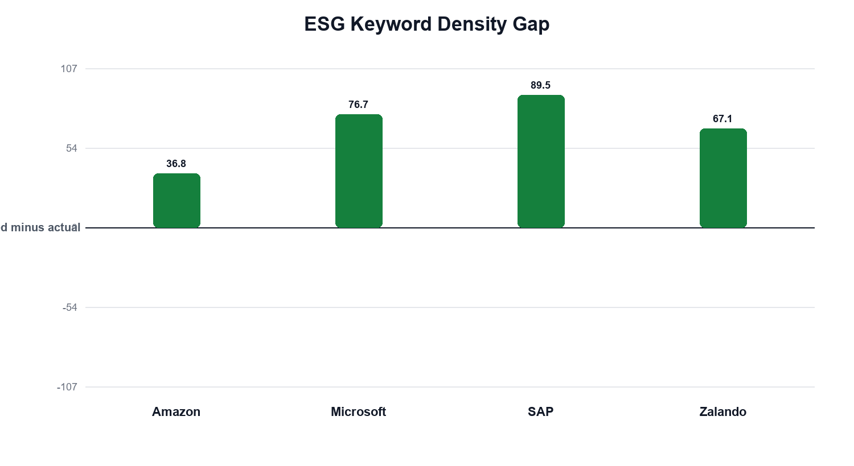
Figure 4. ESG keyword-density gap: generated minus actual.
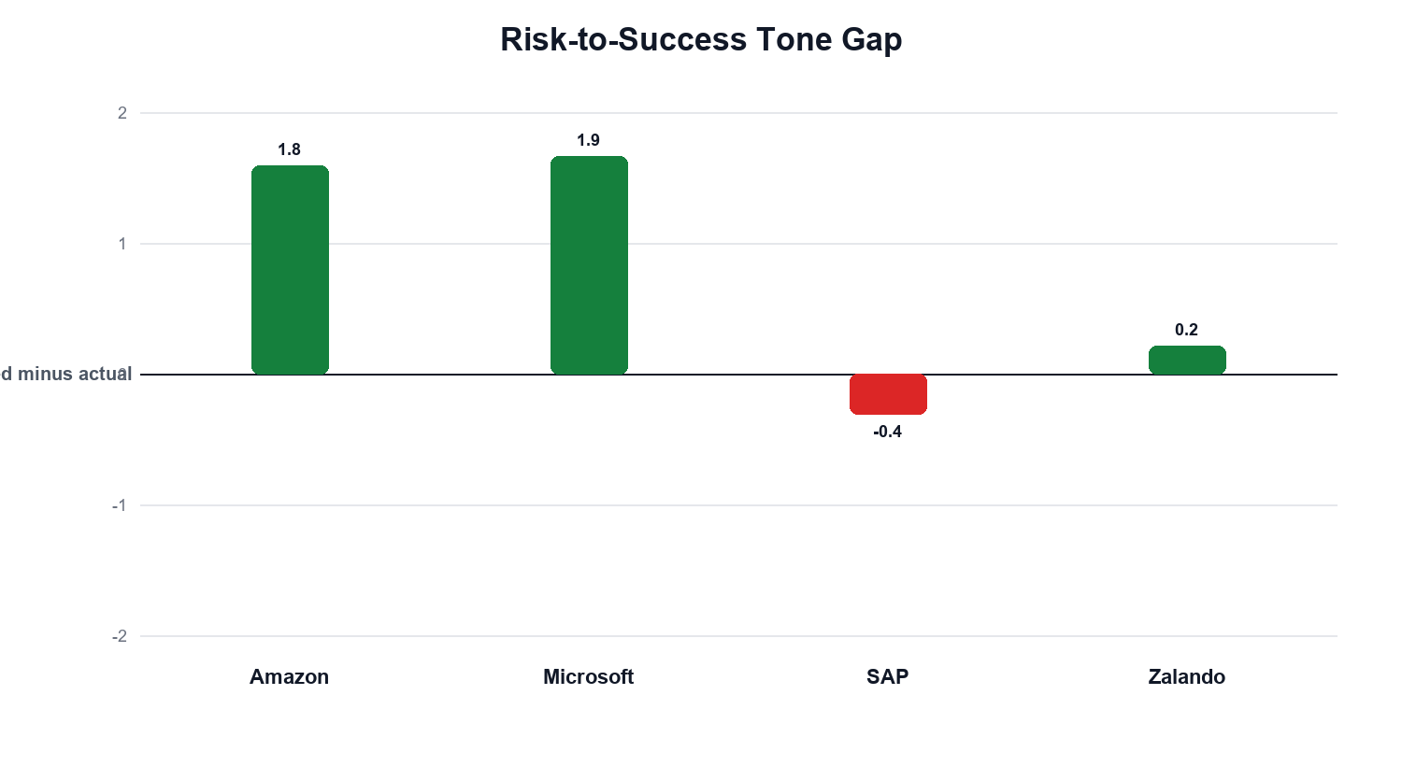
Figure 5. Risk-to-success tone gap: generated minus actual.
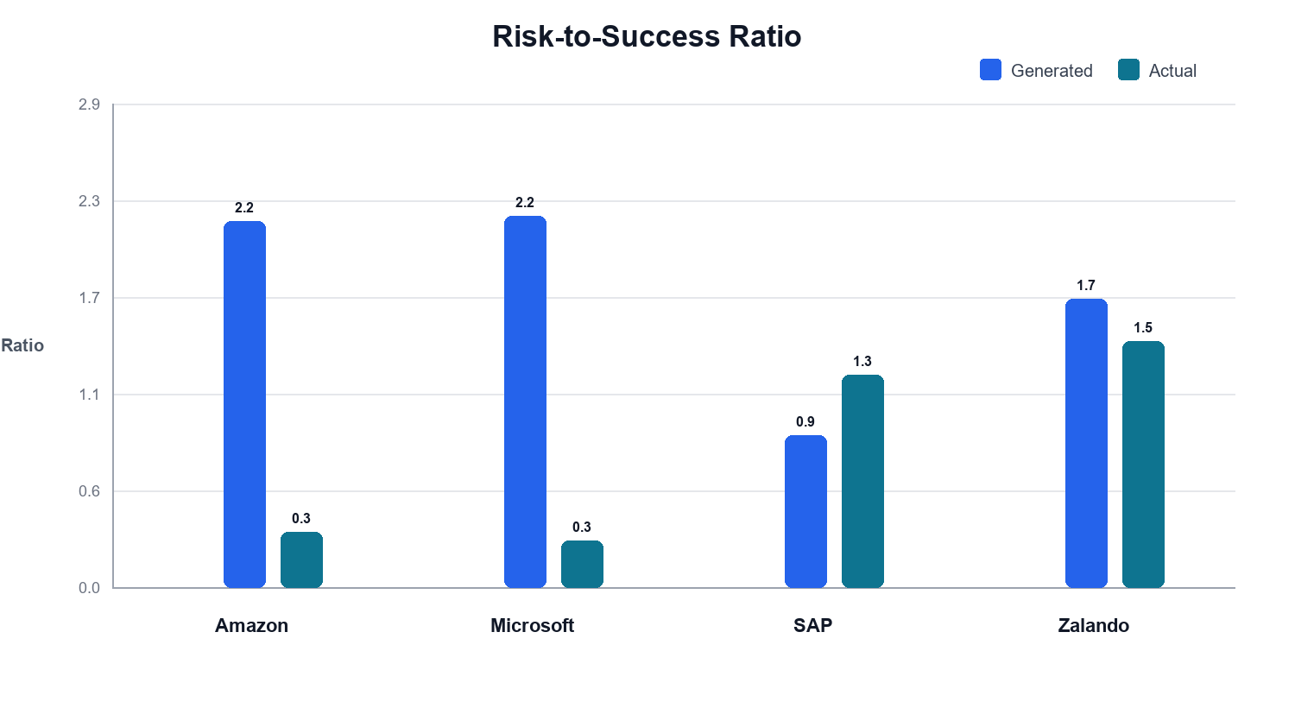
Figure 6. Risk-to-success tone ratios in generated and actual reports.
The generated reports often show high ESG keyword density because they are short and deliberately structured around E, S, and G headings. This does not mean they have more evidence. It means ESG vocabulary is more concentrated. Official reports spread ESG content across broader financial, governance, assurance, and operational disclosure sections.

LLM-Style Qualitative Synthesis
- Factual contradictions: no clear direct contradiction was detected from the generated-vs-actual comparison. The main issue is compression and missing context.
- Missing themes: generated reports underrepresent official framework language, assurance boundaries, table-based indicators, regional or segment detail, and formal materiality language.
- Specificity: generated reports sometimes have high numeric density per 1,000 words, but official reports contain far more total quantified evidence and better audit trails.
- Tone: generated reports tend to be more normalized and balanced; official reports include more granular risk, target, assurance, and compliance language.

Company-Level Interpretation

Amazon
The generated Amazon report captures climate, logistics, workforce, and governance themes, but the official sustainability report contains more operational detail across emissions, packaging, suppliers, safety, and program-level metrics.
Key metrics: TF-IDF cosine 0.2873; Jaccard 0.0615; generated length 2.51% of actual.

Microsoft
The generated Microsoft report is close in broad topic framing but much shorter than the official environmental and impact reports, which provide more detailed cloud, AI, water, energy, and social-impact evidence.
Key metrics: TF-IDF cosine 0.2954; Jaccard 0.0542; generated length 2.29% of actual.

SAP
The SAP comparison now uses the official SAP 2025 Annual Report Form 20-F as a full benchmark after the original 5-page local PDF proved incomplete. The generated report captures governance-heavy framing, while the official filing contains much deeper regulatory, financial, risk, and reporting-boundary language.
Key metrics: TF-IDF cosine 0.2473; Jaccard 0.0455; generated length 0.84% of actual.

Zalando
The generated Zalando report captures fashion-specific ESG issues such as suppliers, returns, circularity, and platform governance, but the official CSRD/ESRS report is far more granular and framework-specific.
Key metrics: TF-IDF cosine 0.2766; Jaccard 0.0548; generated length 0.86% of actual.

Economic Intuition
ESG disclosure is not only a communication exercise. It is a governance and accountability mechanism shaped by regulation, assurance expectations, stakeholder pressure, and sector-specific risk. A reusable AI workflow can standardize report structure and produce comparable ESG summaries, but official reporting remains richer because it must define reporting boundaries, disclose material impacts, and support claims with auditable evidence.

Critical Reflection
- PDF and HTML extraction can miss layout, table structure, footnotes, graphics, and some disclosure context.
- Keyword analysis is transparent and reproducible, but it cannot fully judge factual correctness or materiality.
- Similarity metrics are influenced by document length, boilerplate, and reporting-framework vocabulary.
- The generated reports should be treated as structured ESG summaries, not as replacements for official reports.
- The final project conclusion should emphasize both the usefulness of AI-assisted drafting and the need for human validation against official disclosures.

Source Note
The SAP Integrated Report 2025 PDF is officially listed on SAP Investor Relations, but SAP's CDN blocked direct local shell download in this environment. For the reproducible local comparison, SAP's official SEC filing, SAP 2025 Annual Report Form 20-F, was added as the full actual benchmark source.

